**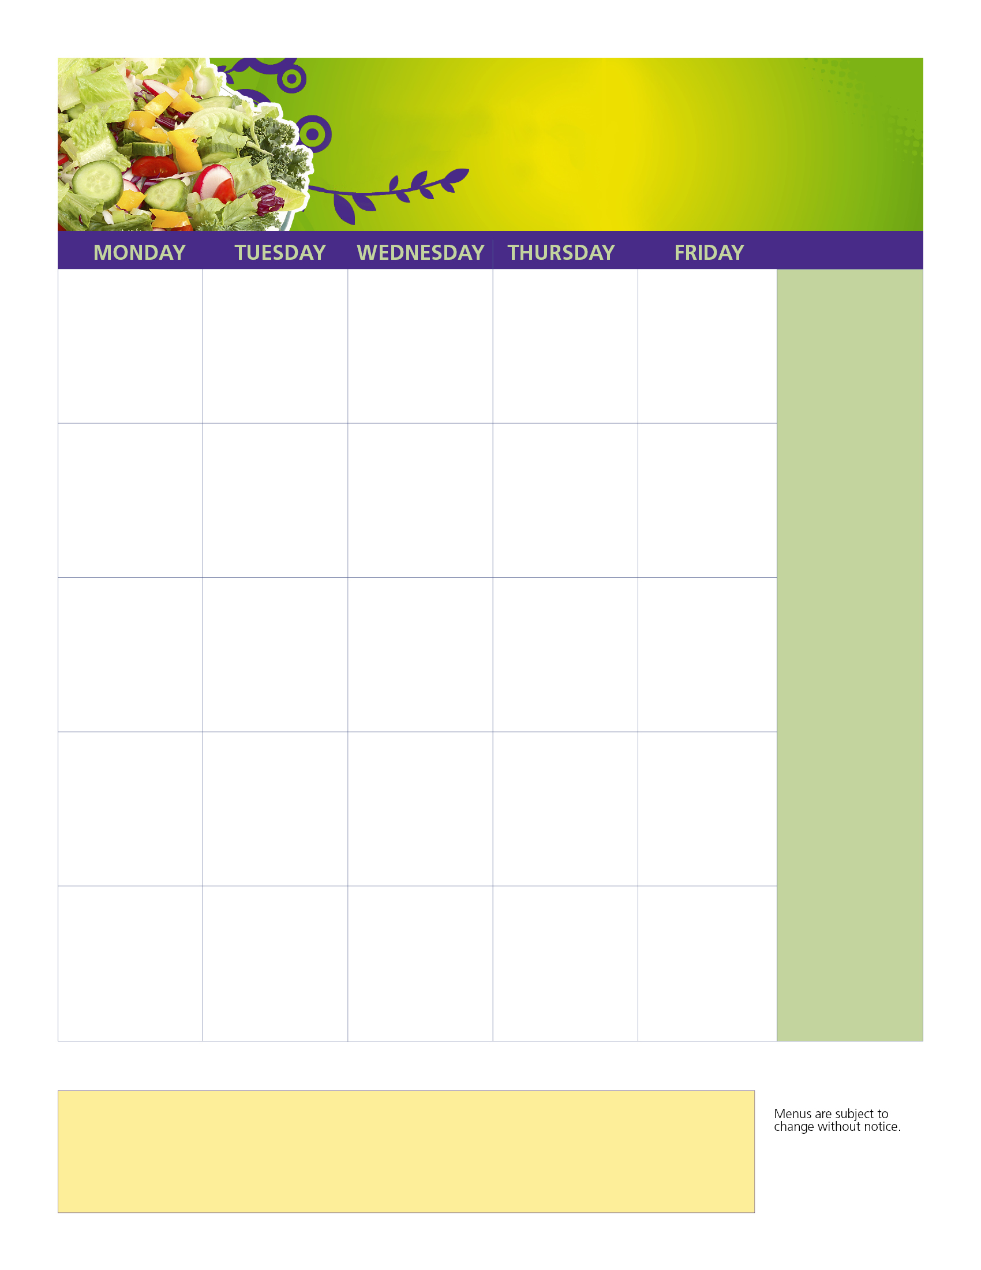**

**Chicken Quesadilla**

**Broccoli Florets**

**Crisp Cucumbers**

**Beef Nachos**

**Broccoli Florets**

**Grape Shaped Tomatoes**

**Top Your Own Baked Potato Bar**

**Broccoli Florets**

**Crunchy Celery**

**Chicken Nugget**

**French Fries**

**Vegetarian Beans**

**Sweet Baby Carrots**

**Fish Filet**

**Sandwich**

**French Fries**

**Carrot Coins**

**Grape Tomatoes**

**Top Your Own**

**Burger Bar**

**Mixed Veggies**

**Sweet Baby Carrots**

**Breakfast for Lunch**

**Sweet Corn**

**Crisp Cucumbers**

**Early Release Day**

**Lunches available**

**In the Cafeteria**

**At Dismissal**

**3030303030302 `**

**31**

**Top Your Own**

**Pasta Bar**

**Mixed Veggies**

**Sweet Baby Carrots**

HAVE A GREAT

SUMMER BREAK!!

**Popcorn Chicken**

**Tater Tot Boat**

**Dinner Roll**

**Sweet Peas**

**Grape Shaped Tomatoes**

**22**

**3**

**22**

**21**

**Sweet Corn**

**Crunchy Celery**

**16**

**3**

**1**

**Breakfast for Lunch**

**Sweet Corn**

**Crisp Cucumbers**

**14**

**hole Grain**

**Pancakes & Chicken Sausage**

**Crisp Corn**

**Crunchy Celery**

**7**

**BREAKFAST**

**A variety of whole grain entrées, (bagel/muffin/cereal bar/cereal/breakfast sandwiches) served with**

**1% milk and a variety of**

**fresh fruit, 100% fruit juice and dried or cupped fruit.**

**FOOD SERVICE OFFICE 617-846-5505 X7210**

MENU SUBJECT TO CHANGE WITHOUT NOTICE

This institution is an equal opportunity provider.

**15**

**Winthrop High/Middle School**

**JUNE 2023**

High/Middle School

**1**

**13**

**12**

**5**

**LUNCH FOR YOU**

**MEALS ARE NO COST TO ALL**

**STUDENTS**

**Every meal comes complete with fresh fruit, fresh veggies, and milk.**

**When possible, we will purchase locally and source out farm to table ingredients**

**EVERYDAY OFFERINGS:**

**Cheeseburgers**

**Chicken Patty**

**Fresh Salads**

**Yogurt Parfaits**

**Deli Bar**

**Veggie Burgers**

**Hummus Veggie Plates**

**Cheese or Pepperoni Pizza**

**Sun Butter & Jelly Sandwich**

**1% milk &**

**Fat Free Chocolate milk offered daily**

**2**

**6**

**29**

**0**

**20**

**19**

**12**

**9**

**8**

**Bright Colors…Big Flavors…**

**23**

**C**

**More Info…**

**Use this space to highlight menu items/ beverages that are served every day to leave the date boxes for special items only.**

**Adjust type size ac-accordingly.**

Aramark_Education-sml